Part 1: 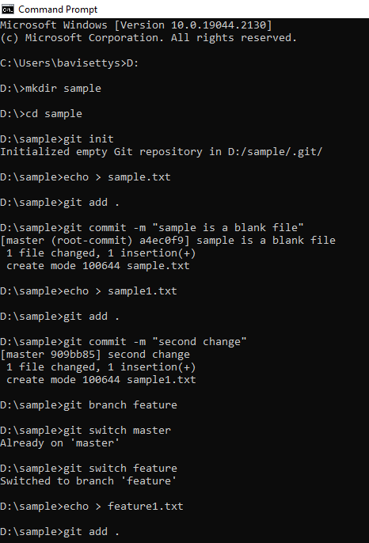Fast forward merge:

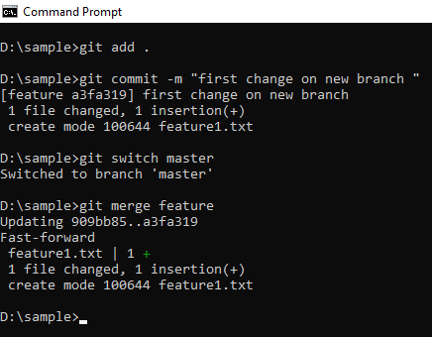

Part 2: Merge Commit (No Conflicts)

Part 3: Conflicts